
American International University – Bangladesh (AIUB)
Faculty of Engineering
Department of CSE, EEE, and CoE

EEE3102 Digital Logic and Circuits LAB
PROJECT PROPOSAL FORM

SEMESTER: Fall 2023-2024
PROJECT TITLE: PASSWORD SECURITY SYSTEM
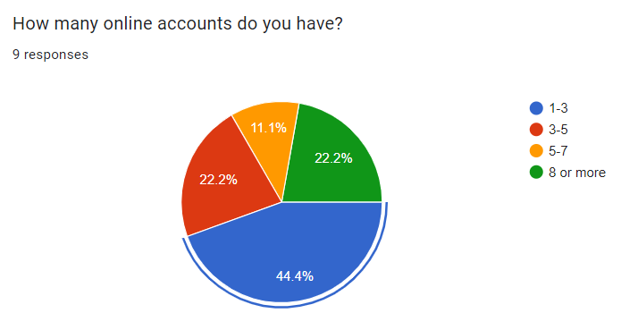
Survey to develop a process for complex engineering problems with a wide range of conflicting requirements (use pie chart):
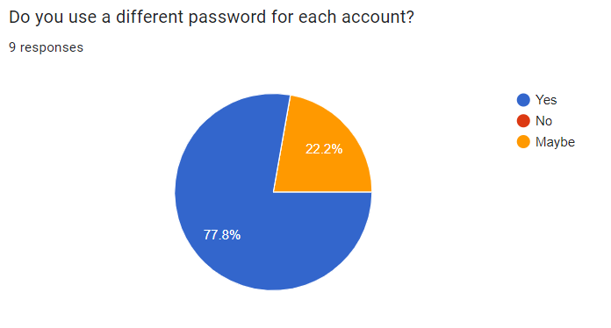
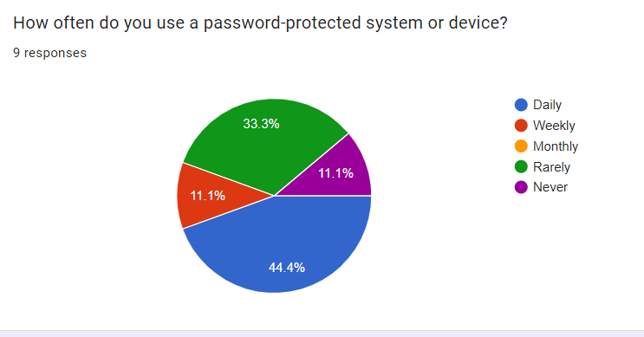
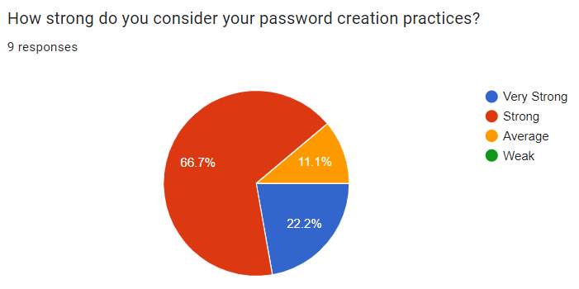

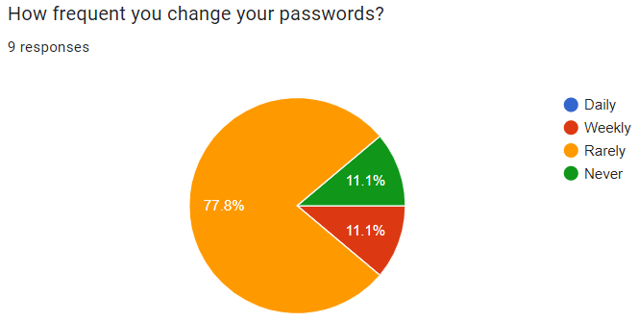

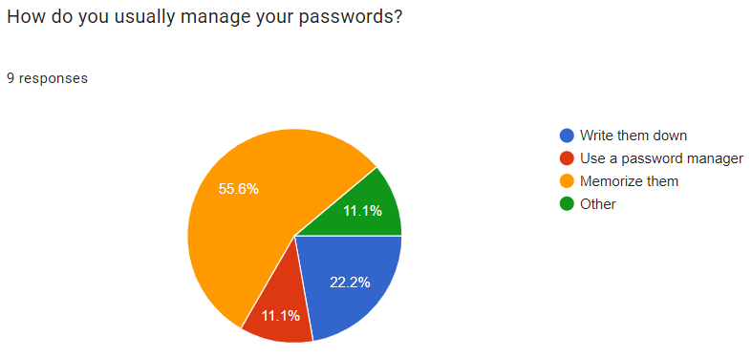

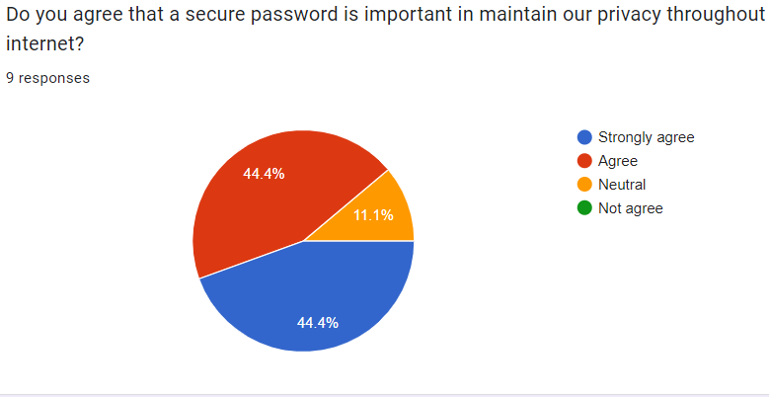

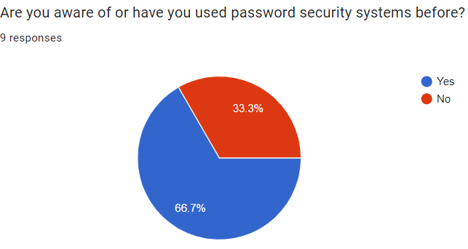

AIMS AND OBJECTIVES OF THE PROJECT:
To develop and implement a Password Security System that safeguards user accounts and sensitive information from unauthorized access and data breaches.

LITERATURE REVIEW:
The proposed project, titled "Password Security System," aims to design and implement a digital logic system to enhance access control and security in various applications, such as homes, offices, and personal devices. Password-based authentication is a fundamental aspect of modern security systems, and this project seeks to develop an efficient and reliable solution. The system will consist of an input interface for users to enter a password, which will be compared to a pre-stored, secure password. When the entered password matches the stored one, a green LED indicator will illuminate to grant access; otherwise, a red LED will signify denied access. This project will leverage digital logic gates, memory elements to create a cost-effective and low-power security system. By conducting a comprehensive literature review, this proposal identifies the existing literature on digital logic-based access control systems, password security, and LED indicator designs. It will critically assess the strengths and limitations of prior works to inform the design and implementation of an innovative and reliable Password Security System, contributing to the field of digital logic and security technology.

EXPERIMENTAL BLOCK DIAGRAM:

PASSWORD SECURITY SYSTEM

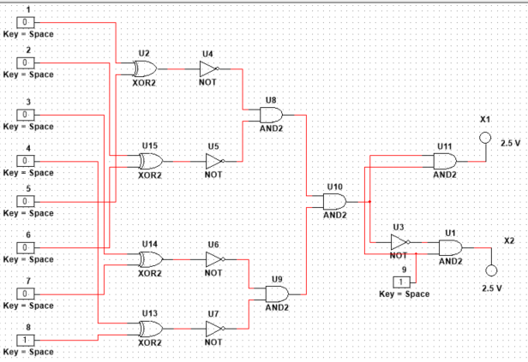

PROJECT TIMELINE (GANTT CHART):

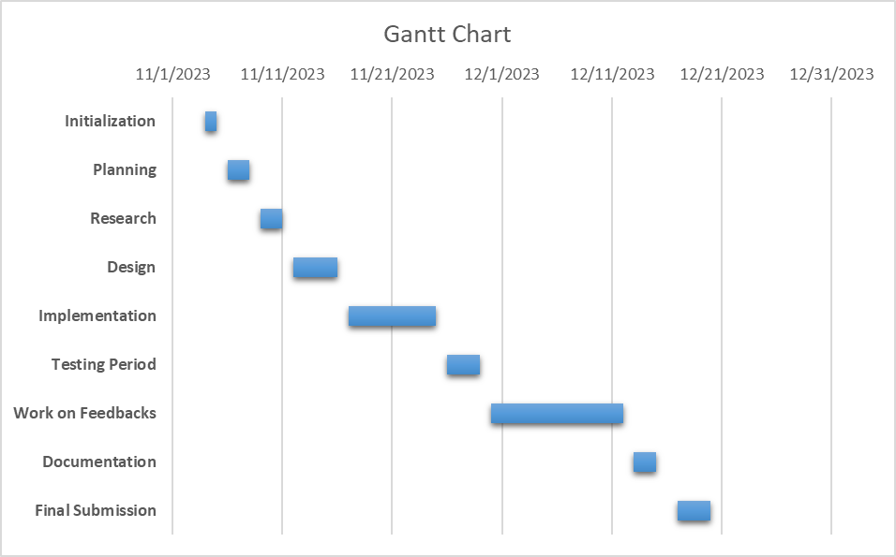
REFERENCES:
[1] B. Queensland. (2016, 13 June) ”Beneﬁts of doing
business online”. Accessed: 07-09-2020. [Online]. Avail-
able: https://www.business.qld.gov.au/starting-business/internet-start-
ups/online-basics/beneﬁts
[2] A. to Information (A2I) Programme: Prime Minister’s Ofﬁce. (2011,
January) Strategic priorities of digital bangladesh. [Accessed: 07-09-
2020]. [Online]. Available: https://a2i.gov.bd/wp-content/uploads/2017/
11/4-Strategy Digital Bangladesh 2011.pdf
[3] K. Zetter. (2016, 17 May) “That Insane, $81M Bangladesh
Bank Heist? Here’s What We Know”. [Online; accessed 07-09-
2020]. [Online]. Available: https://www.wired.com/2016/05/insane-
81m-bangladesh- bank-heist- heres-know/
[4] R. Sobers. (2020, 21 July) 110 must-know cybersecurity statistics
for 2020. [Accessed: 07-09-2020]. [Online]. Available: https://
www.varonis.com/blog/cybersecurity-statistics/
[5] L. Arezina. (2019, 19 November) Password statistics for 2020.
[Accessed: 07-09-2020]. [Online]. Available: https://dataprot.net/
statistics/password-statistics/
[6] D. V. Klein, “Foiling the cracker: A survey of, and improvements
to, password security,” in Proceedings of the 2nd USENIX Security
Workshop, 1990, pp. 5–14.
[1] B. Queensland. (2016, 13 June) ”Beneﬁts of doing
business online”. Accessed: 07-09-2020. [Online]. Avail-
able: https://www.business.qld.gov.au/starting-business/internet-start-
ups/online-basics/beneﬁts
[2] A. to Information (A2I) Programme: Prime Minister’s Ofﬁce. (2011,
January) Strategic priorities of digital bangladesh. [Accessed: 07-09-
2020]. [Online]. Available: https://a2i.gov.bd/wp-content/uploads/2017/
11/4-Strategy Digital Bangladesh 2011.pdf
[3] K. Zetter. (2016, 17 May) “That Insane, $81M Bangladesh
Bank Heist? Here’s What We Know”. [Online; accessed 07-09-
2020]. [Online]. Available: https://www.wired.com/2016/05/insane-
81m-bangladesh- bank-heist- heres-know/
[4] R. Sobers. (2020, 21 July) 110 must-know cybersecurity statistics
for 2020. [Accessed: 07-09-2020]. [Online]. Available: https://
www.varonis.com/blog/cybersecurity-statistics/
[5] L. Arezina. (2019, 19 November) Password statistics for 2020.
[Accessed: 07-09-2020]. [Online]. Available: https://dataprot.net/
statistics/password-statistics/
[6] D. V. Klein, “Foiling the cracker: A survey of, and improvements
to, password security,” in Proceedings of the 2nd USENIX Security
Workshop, 1990, pp. 5–14.
[1] B. Queensland. (2016, 13 June) ”Beneﬁts of doing
business online”. Accessed: 07-09-2020. [Online]. Avail-
able: https://www.business.qld.gov.au/starting-business/internet-start-
ups/online-basics/beneﬁts
[2] A. to Information (A2I) Programme: Prime Minister’s Ofﬁce. (2011,
January) Strategic priorities of digital bangladesh. [Accessed: 07-09-
2020]. [Online]. Available: https://a2i.gov.bd/wp-content/uploads/2017/
11/4-Strategy Digital Bangladesh 2011.pdf
[3] K. Zetter. (2016, 17 May) “That Insane, $81M Bangladesh
Bank Heist? Here’s What We Know”. [Online; accessed 07-09-
2020]. [Online]. Available: https://www.wired.com/2016/05/insane-
81m-bangladesh- bank-heist- heres-know/
[4] R. Sobers. (2020, 21 July) 110 must-know cybersecurity statistics
for 2020. [Accessed: 07-09-2020]. [Online]. Available: https://
www.varonis.com/blog/cybersecurity-statistics/
[5] L. Arezina. (2019, 19 November) Password statistics for 2020.
[Accessed: 07-09-2020]. [Online]. Available: https://dataprot.net/
statistics/password-statistics/
[6] D. V. Klein, “Foiling the cracker: A survey of, and improvements
to, password security,” in Proceedings of the 2nd USENIX Security
Workshop, 1990, pp. 5–14.
[1] B. Queensland. (2016, 13 June) ”Beneﬁts of doing
business online”. Accessed: 07-09-2020. [Online]. Avail-
able: https://www.business.qld.gov.au/starting-business/internet-start-
ups/online-basics/beneﬁts
[2] A. to Information (A2I) Programme: Prime Minister’s Ofﬁce. (2011,
January) Strategic priorities of digital bangladesh. [Accessed: 07-09-
2020]. [Online]. Available: https://a2i.gov.bd/wp-content/uploads/2017/
11/4-Strategy Digital Bangladesh 2011.pdf
[3] K. Zetter. (2016, 17 May) “That Insane, $81M Bangladesh
Bank Heist? Here’s What We Know”. [Online; accessed 07-09-
2020]. [Online]. Available: https://www.wired.com/2016/05/insane-
81m-bangladesh- bank-heist- heres-know/
[4] R. Sobers. (2020, 21 July) 110 must-know cybersecurity statistics
for 2020. [Accessed: 07-09-2020]. [Online]. Available: https://
www.varonis.com/blog/cybersecurity-statistics/
[5] L. Arezina. (2019, 19 November) Password statistics for 2020.
[Accessed: 07-09-2020]. [Online]. Available: https://dataprot.net/
statistics/password-statistics/
[6] D. V. Klein, “Foiling the cracker: A survey of, and improvements
to, password security,” in Proceedings of the 2nd USENIX Security
Workshop, 1990, pp. 5–14.
[1] B. Queensland. (2016, 13 June) ”Beneﬁts of doing
business online”. Accessed: 07-09-2020. [Online]. Avail-
able: https://www.business.qld.gov.au/starting-business/internet-start-
ups/online-basics/beneﬁts
[2] A. to Information (A2I) Programme: Prime Minister’s Ofﬁce. (2011,
January) Strategic priorities of digital bangladesh. [Accessed: 07-09-
2020]. [Online]. Available: https://a2i.gov.bd/wp-content/uploads/2017/
11/4-Strategy Digital Bangladesh 2011.pdf
[3] K. Zetter. (2016, 17 May) “That Insane, $81M Bangladesh
Bank Heist? Here’s What We Know”. [Online; accessed 07-09-
2020]. [Online]. Available: https://www.wired.com/2016/05/insane-
81m-bangladesh- bank-heist- heres-know/
[4] R. Sobers. (2020, 21 July) 110 must-know cybersecurity statistics
for 2020. [Accessed: 07-09-2020]. [Online]. Available: https://
www.varonis.com/blog/cybersecurity-statistics/
[5] L. Arezina. (2019, 19 November) Password statistics for 2020.
[Accessed: 07-09-2020]. [Online]. Available: https://dataprot.net/
statistics/password-statistics/
[6] D. V. Klein, “Foiling the cracker: A survey of, and improvements
to, password security,” in Proceedings of the 2nd USENIX Security
Workshop, 1990, pp. 5–14.
[1] A Study of Password Security Factors among Bangladeshi Government Websites(December 2020) Adil Ahmed Chowdhury Leading University, Md. Sadek Ferdous BRAC University. [Accessed: 07-09-2020]. [Online]. Available:
https://www.researchgate.net/publication/346614538_A_Study_of_Password_Security_Factors_among_Bangladeshi_Government_Websites
[2] L. Arezina. (2019, 19 November) Password statistics for 2020.[Accessed: 07-09-2020]. [Online]. Available: https://dataprot.net/statistics/password-statistics/
[2] D. V. Klein, “Foiling the cracker: A survey of, and improvementsto, password security,” in Proceedings of the 2nd USENIX SecurityWorkshop, 1990, pp. 5–14.
[7] M. Raza, M. Iqbal, M. Sharif, and W. Haider, “A survey of password
attacks and comparative analysis on methods for secure authentication,”
World Applied Sciences Journal, vol. 19, no. 4, pp. 439–444, 2012.
[8] P. Hoonakker, N. Bornoe, and P. Carayon, “Password authentication
from a human factors perspective: Results of a survey among end-users,”
in Proceedings of the Human Factors and Ergonomics Society Annual
Meeting, vol. 53, no. 6. SAGE Publications Sage CA: Los Angeles,
CA, 2009, pp. 459–463.
[9] A. Das, J. Bonneau, M. Caesar, N. Borisov, and X. Wang, “The tangled
web of password reuse.” in NDSS, vol. 14, no. 2014, 2014, pp. 23–26.
[3] M. Raza, M. Iqbal, M. Sharif, and W. Haider, “A survey of passwordattacks and comparative analysis on methods for secure authentication,”World Applied Sciences Journal, vol. 19, no. 4, pp. 439–444, 2012.
[4] P. Hoonakker, N. Bornoe, and P. Carayon, “Password authenticationfrom a human factors perspective: Results of a survey among end-users,”in Proceedings of the Human Factors and Ergonomics Society AnnualMeeting, vol. 53, no. 6. SAGE Publications Sage CA: Los Angeles,CA, 2009, pp. 459–463.

FACULTY USE ONLY
COMMENTS BY THE COURSE TEACHER:

COURSE TEACHER’S NAME COURSE TEACHER’S SIGNATURE DATE
GROUP MEMBERS:
(Maximum 6 students are permitted to carry out a single Project. However, depending on the capability of the students, 4 students may be allowed but not less than that)

NAME: LIDA KHAN MUKTI  ID: 22-47000-1  PROGRAM: CSE  EMAIL: lidakhan1971@gmail.com | NAME: MD. JAHID HASAN  ID: 22-47010-1  PROGRAM: CSE  EMAIL: jahid.hasan1217@gmail.com
NAME: FARJANA YESMIN OPI  ID: 22-47018-1  PROGRAM: CSE  EMAIL: farjanaopi11@gmail.com | NAME: MD. ABU TOWSIF  ID: 22-47019-1  PROGRAM: CSE  EMAIL: towsif1528@gmail.com
NAME: NAZIM-E-ALAM  ID: 22-47047-1  PROGRAM: EEE/COE/CSE  EMAIL: nazimriyadh001@gmail.com | NAME: ………………………………………………  ID………………………………  PROGRAM: EEE/COE/CSE  EMAIL:
REMARKS (for OFFICE use only)

Course Outcome Mapping with the Course Project Proposal:
COs/CLOs |  | Details |  | K | P | A | Assessed Program Outcome Indicator | BNQF Indicator | Assessment Techniques
CO1 |  | Apply proper information and concepts of different logic gates, digital ICs, transistors, and timers to implement logical circuits considering a wide range of conflicting requirements. |  | K3 | P1,  P2,  P6 |  | P.a.3.C3 | FS.1 | Course Project Proposal Form
Course Name: |  |  | Digital Logic and Circuits Lab |  |  |  | Course Code: |  | EEE 3102
Semester: |  |  | Spring 2022-2023 |  |  |  | Section: |  | L
Faculty Member: |  |  | NUZAT NUARY ALAM
Course Project Title: |  |  | PASSWORD SECURITY SYSTEM
Project Group No. |  |  | 07
SL | Student ID # |  | Student Name |  |  |  | Obtained Marks
1. | 22-47000-1 |  | LIDA KHAN MUKTI
2. | 22-47010-1 |  | MD. JAHID HASAN
3. | 22-47018-1 |  | FARJANA YESMIN OPI
4. | 22-47019-1 |  | MD. ABU TOWSIF
5. | 22-47047-1 |  | NAZIM-E-ALAM
6.

Assessment Materials and Marks Allocation:
COs | Assessment Materials | POIs | Marks
CO1 | Course Project Proposal form | P.a.3.C3 | 20

Assessment Rubrics
COs-POIs | Excellent  [17-20] | Proficient  [13-16] | Good  [9-12] | Acceptable  [5-8] | Unacceptable  [1-4] | No Response  [0] | Secured Marks
CO1  P.a.3.C3 | The survey developed as a process for complex engineering problems considering a wide range of conflicting requirements and  implementation process is clear and challenging for future project implementation. | The survey developed as a process for complex engineering problems considering a wide range of conflicting requirements but the conflicting requirements are less in number and  implementation process is clear and challenging for future project implementation. | The survey developed as a process for complex engineering problems considering a wide range of conflicting requirements but the conflicting requirements are less in number and  implementation process is not so clear but seems challenging for future project implementation. | The survey developed as a process for complex engineering problems considering a wide range of conflicting requirements but the conflicting requirements are fewer in number and  implementation process is not so clear and seems less challenging for future project implementation. | The survey developed as a process for complex engineering problems considering a wide range of conflicting requirements but the conflicting requirements are very few in number and  implementation process is not clear at all and seems impractical for future project implementation. | No Response
Comments |  |  |  |  |  | Total marks (20)

